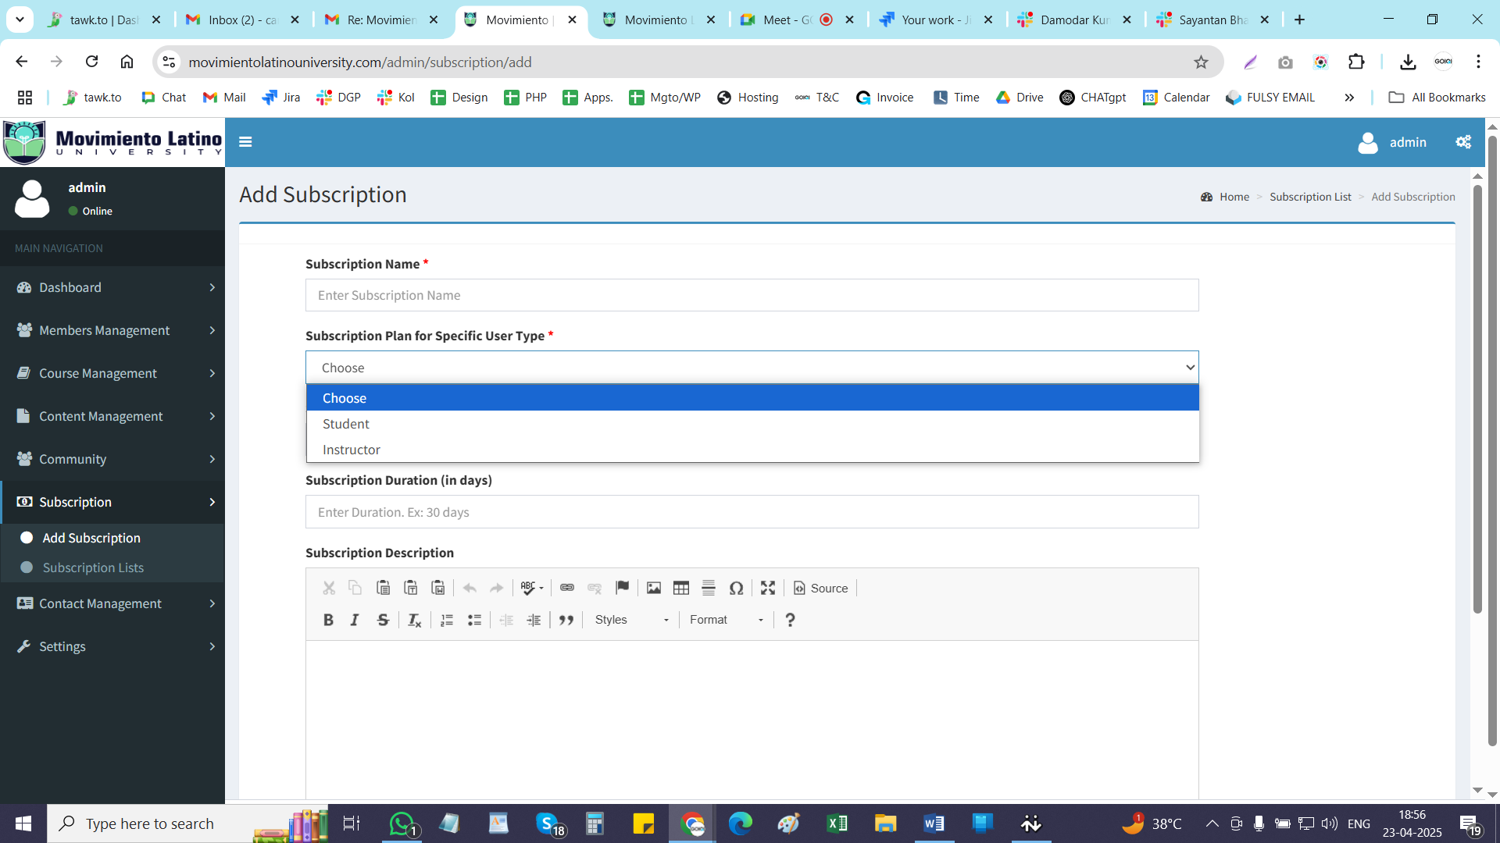

**Admin will create Subscription Package – only for Instructor**

**Admin will create courses – and assign courses to an instructor. (INSTRUCTORS WILL NOT CREATE COURSES IN THIS VERSION)**

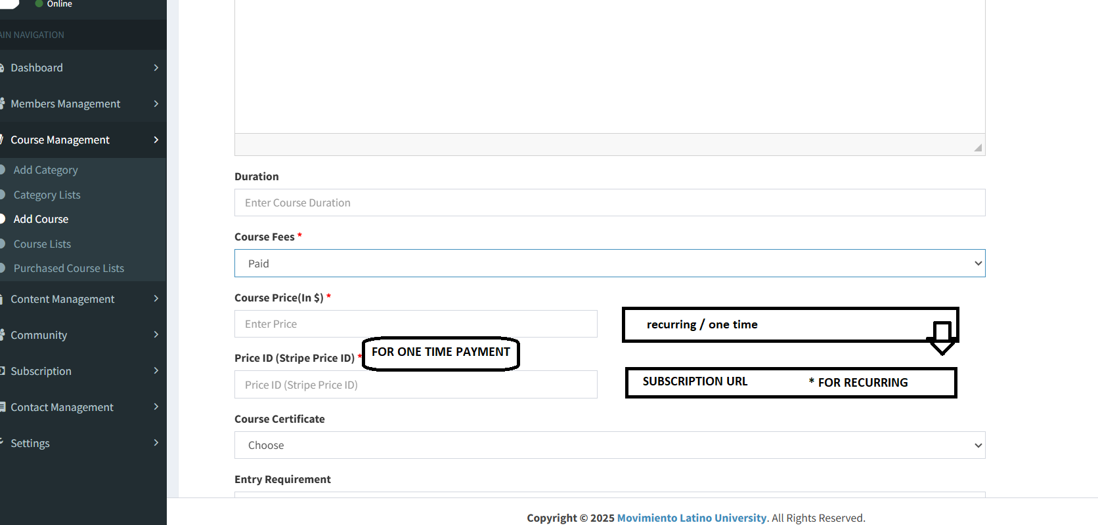

**ON THE FRONTEND:  
  
